**Save Button prefab Readme File**

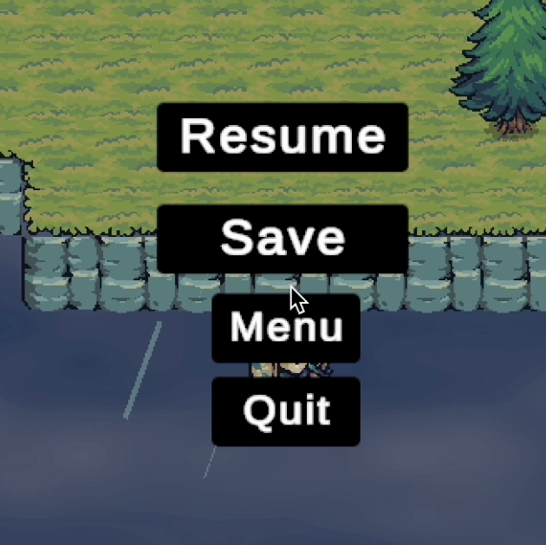

**Description**

This prefab provides a functional **Save Game** button to be used within your Unity pause menu. It integrates with the PauseGameMenu script and leverages Unity’s PlayerPrefs system to store the player's current position.

This prefab is ideal for Unity projects needing a simple yet reliable save function accessible from the pause menu.

**Features:**

**Save Game Button:**

* Triggers the SaveGame() method in PauseGameMenu.cs.
* Records player’s current position (x, y, z) using PlayerPrefs.
* Provides confirmation via Debug log or optional UI feedback.

**Menu Integration:**

* Designed to be placed inside the PauseGameMenu UI Panel.
* Automatically hooks into Unity’s UI event system (OnClick).

**Requirements:**

* Unity 2020.3 or later (tested on 2022.3)
* Pause Menu UI using Unity Canvas system
* Active PauseGameMenu script with SaveGame() method
* Compatible Input System (Unity Input System or legacy)

**Usage:**

**Trigger the Pause Menu:**

* Use the assigned key (e.g., Escape) to open the PauseGameMenu.

**Click Save Button:**

* The Save Game button prefab should already be linked to the SaveGame() function in the Inspector using OnClick().

**What It Does:**

* Saves the player's current position in the game scene using: